Conservation District Considerations Regarding Renewable Energy Projects in Washington State

Developed by the WACD Renewable Energy Workgroup

September 30, 2024

**Introduction:** The Renewable Energy Workgroup’s goal is to define renewable resources, highlight the opportunities and challenges presented by large-scale renewable energy projects, and develop recommended position statements that address impacts on working lands, wildlife, cultural and natural resources, and the need for mitigating at the local level.

The workgroup incorporated the following three approved resolutions into their review process:

**2021-06**: WACD will develop a position statement to address the conversion of working lands to solar farms. And the effect of taking working lands out of production to mitigate solar farms. And to present a recommendation on the position at the Annual Business Meeting in 2022.

**2023-05**: WACD will develop a task force that explores the topic of hydropower as a renewable resource and develop a position statement for consideration by the membership at the 2024 WACD annual meeting.

**2023-09**: Work with partners to encourage EFSEC not to bypass local authority when siting new solar and wind installations and ensure sufficient environmental and habitat studies can be done on the impact to shrub-steppe habitat.

The Work Group consists of nine Conservation District Supervisors and Managers/Executive Directors: Jim Baye, Lincoln County CD; Claire Crawbuck, San Juan Island CD; Aneesha Dieu, Columbia CD; Clay Hutchens, Columbia CD; Kara Kaelber, Benton/Franklin CDs; Mike Nordin, Pacific CD; Kristina Ribellia, Columbia Basin CD; and Carson Sprenger, San Juan Island CD, Mike Tobin, North Yakima CD. The Workgroup received staff support from Heather Wendt, WACD’s Director of Development and Engagement.

**Background:** The Shared Resources workgroup began meeting in March of 2023. The workgroup heard from several subject matter experts to better understand the issues around large-scale renewable energy projects and potential mitigation strategies.

## Defining Renewable Resources

"Renewable resource" refers to energy sources that are naturally replenished and sustainable over time. These resources include:

(a) Water (hydropower);

(b) Wind;

(c) Solar energy;

(d) Geothermal energy;

(e) Landfill gas;

(f) Wave, ocean, or tidal power (collectively known as offshore energy);

(g) Gas from sewage treatment facilities;

(h) Biodiesel fuel, provided it is not derived from crops raised on land cleared from old-growth or first-growth forests where the clearing occurred after December 7, 2006;

(i) Biomass energy.

## An Overview of Renewable Energy Production in Washington State[1]

Per the U.S. Energy Information Administration, Washington State is the nation's largest hydroelectric power producer. In 2023, hydroelectric power accounted for 60% of Washington's total electricity net generation. Natural gas, nonhydroelectric renewable resources (mostly wind), nuclear energy, and coal provide almost all the rest of Washington's in-state electricity generation. Renewable resources other than hydroelectric power accounted for about 10% of state generation. Wind represented almost four-fifths of that share. Biomass and solar energy supplied the rest of the renewable generation. Nuclear energy provided about 8% of Washington's total in-state generation (See Figure 1 below).

Figure 1 – Washington Energy Consumption Estimates, 2022[2]

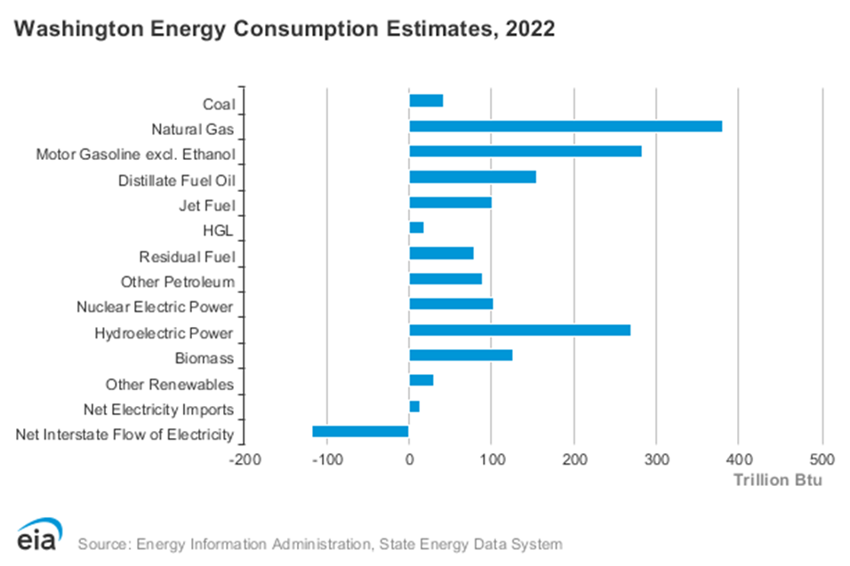

## Overview of Renewable Energy Project Locations

The highest density of land-based existing and proposed renewable energy projects are in the Columbia Gorge along the southern border of Washington and throughout central and eastern Washington (See Figures 2 and 3). Note: Per the Department of Commerce[3], a 2011 settlement will close the Centralia Coal Plant by the end of 2025 (shown by the red dot in Figure 2 below). Figures 4 and 5 show the location of two proposed offshore wind projects covering a total of 700 square miles off the coast of Grays Harbor and Pacific Counties.[4]

Figure 2 – Top power producers in each category and region (as of April 2024)[5]

](https://www.nwcouncil.org/energy/energy-topics/power-supply/map-of-power-generation-in-the-northwest/)

Figure 3 – Composite Map of Solar and Wind Projects, Washington State, WDFW[6]

## Figure 4 – Hectate Energy’s Cascadia Wind Project Proposal Map[7]

## [A map of the ocean Description automatically generated](https://www.cascadiaoffshorewind.com/documents/Hecate_CascadiaWind_AreaofInterestMap_20221104.pdf)

Figure 5 – Trident Winds’ Olympic Wind Project Proposal Map[8]

## [A map of the coast Description automatically generated](https://tridentwinds.com/wp-content/uploads/2022/04/proposed-olympic-wind-lease-area_2022_0412_landscape.pdf)

## Overview of Renewable Energy Regulations in Washington State

**Energy Independence Act of 2007 RCW 19.285**

The Energy Independence Act (EIA or I-937) requires electric utilities serving at least 25,000 retail customers to use renewable energy and energy conservation. The Act applies to 18 utilities that provide 80 percent of the electricity sold to Washington retail customers. The 18 utilities are required to obtain fifteen percent of their electricity from new renewable resources such as solar and wind by 2020 and undertake cost-effective energy conservation. Hydropower is excluded from the 15% unless it comes from generation due to efficiency improvements made after 1999.[9]

**Washington Clean Energy Transformation Act RCW 19.405**

The Clean Energy Transformation Act (CETA) (SB 5116) became law in May 2019. It commits Washington to an electricity supply free of greenhouse gas emissions by 2045. This will require the state to replace fossil fuels in end uses. Unlike the Energy Independence Act CETA allows for hydropower to be counted as a renewable resource and the energy produced is counted toward CETA’s goals:

RCW 19.405.020(34) "Renewable resource" means: (a) Water; (b) wind; (c) solar energy; (d) geothermal energy; (e) renewable natural gas; (f) renewable hydrogen; (g) wave, ocean, or tidal power; (h) biodiesel fuel that is not derived from crops raised on land cleared from old growth or first growth forests; or (i) biomass energy.

## Benefits of Renewable Energy Projects

Large-scale renewable energy projects provide numerous opportunities, including:

* Lower Energy Costs – In 2023, Washington had the ninth-lowest average electricity prices in the nation. (See Figure 6 below) The residential sector, where almost three in five households use electricity as their primary heating source, accounted for 44% of Washington's electricity sales in 2023. The commercial sector used 33% of the state's electricity, and the industrial sector accounted for 23%.[10]
* Environmental Benefits – Reduction in greenhouse gas emissions, conservation of finite natural resources, and a cleaner, healthier environment for future generations.
* Energy Security – Increased energy independence through diversified energy sources, reducing reliance on external and non-renewable energy markets.
* Dual Use – Where solar and wind technologies share the same land with other land uses, such as agriculture, this may help balance renewable energy goals. It should be noted that a reduced level of agricultural viability may occur, but dual use may reduce the overall impact of land conversion[11]

Figure 6 – Washington Price Differences from U.S. Average, Most Recent Monthly[12]

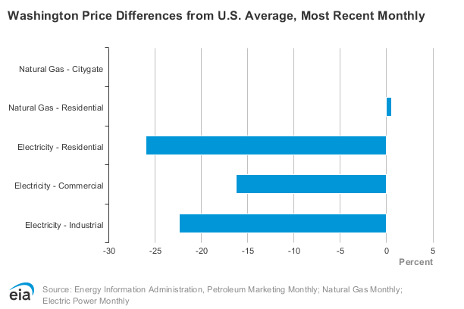

## Challenges of Renewable Energy Projects

Large-scale renewable projects present challenges at the local level, including:

**Environmental Impacts**: Potential disruption to ecosystems, water and soil resources, wildlife, habitats, and protected species during construction and operation.

* Wildlife Considerations – Construction and operation of solar and wind facilities may result in significant adverse impacts to special-status habitats and species. Impacts may result in degradation, loss, or conversion of suitable habitat that is critical to species viability; disruption of successful breeding and rearing behaviors; disruption of habitat continuity along migration routes, or mortality of individuals.[13] Off-shore renewable energy projects have noted environmental concerns including injury to protected species (i.e., whales, and seabirds).[14]
* Soil Property Changes – According to research installation of solar panels can induce significant changes in soils' physical, chemical, and biochemical properties requiring remediation before land can be converted back to agricultural use.[15]
* Recycling Concerns – There are significant concerns regarding the sheer amount of waste that will be produced when solar panels reach their life expectancy of 30 years, provided they are not replaced with more efficient models earlier. According to the International Renewable Agency, by 2050 in the United States, it could amount to 7.5 million to 10 million tons of waste.[16] Panels do contain small amounts of valuable materials such as silver, but they are mostly made of glass making them low-value recycling candidates. Some governments may classify solar panels as hazardous waste, due to the small amounts of heavy metals (cadmium, lead, etc.) they contain leading to further recycling and disposal challenges.[17]

Solar panels are not the only renewable energy sector dealing with this issue, the cumulative mass of decommissioned wind turbine blades in the US will reach 1.5 million metric tons by 2040 and 2.2 million metric tons by 2050.[18] As a result, several manufacturers of wind turbine blades have teamed up with recycling companies and makers of construction materials to convert retired blades into useful products. As an example, GE and Veolia North America are converting retired blades to cement.[19]

* Lithium Batteries – Lithium batteries are used to power electric vehicles, and to store wind and solar-generated power. Australia, Chile, and China produce 90% of the world’s lithium. Lithium mining uses large quantities of water, and produces large quantities of mineral waste, and the sulfuric acid and sodium hydroxide used for extraction can contaminate the soil and water.[20], [21] More work needs to be done to recycle existing batteries and find alternative materials to develop new batteries.

**Cultural and Land-Use Concerns**: Conflicts with local customs, cultures, and the use of working lands for agriculture, fishing, and recreation.

* Off-shore Renewable Energy Projects – There are concerns regarding the effects of displacement of fishing, effects on processors and the infrastructure that supports the fishing industry, and on tribal fishing rights, resources, and communities.[22], [23]
* Land-Based Renewable Energy Projects – Washington State tribes have expressed concerns regarding projects located on sacred sites and in areas that have the potential to impact cultural resources.[24] In addition to cultural resource concerns, the conversion of prime farmland is also of significant concern. American Farmland Trust estimates that nationally 83% of solar land conversion projected to occur by 2040 will occur on agricultural lands and 49% of the total agricultural land conversion will occur on Nationally Significant land. Nationally Significant land is the land best suited to intensive food and other crop production with the fewest environmental impacts.[25]

**Community Impacts**: Concerns related to land use, visual impacts, noise, and changes in community character.

* Social Justice - There are social justice concerns with large-scale projects, the wealth generated does not stay within the community impacted at a proportion that is equitable to that community.
* Post-Project Remediation - Project approvals should require clean-up/remediation after the energy project is completed (or other causes such as fire, storm, bankruptcy, etc...) to ensure that the converted site will be returned to pre-project conditions.

**Lack of Sufficient and Aging Infrastructure**: The state’s power needs are expected to increase 97 percent by 2050. The existing transmission infrastructure may not be sufficient to move new renewable energy across the grid.[26]

**Meeting Demand**: CETA sets ambitious goals for Washington State to transition to 100% clean electricity by 2045. While the state is currently an exporter of energy, helping to keep power costs low for residents, there are growing concerns that the CETA requirements may lead to an inability to meet in-state energy demands by 2050.[27]

## Examples of Renewable Energy Projects and Plans

The workgroup explored examples of projects and plans in Washington State that are examples that would be supported by the proposed position statements.

**Yakama Tribal Solar Canal & Hydro Project**

Yakama Tribal Solar Canal & Hydro Project on the Yakama Indian Reservation will convert inefficient, open-water irrigation canals into a solar and micro-hydropower irrigation system. According to Solar Washington, this cutting-edge system could conserve up to 20% more water and help energy-burdened residents save up to 15% on their utility bills. Additionally, the project will build solar panels on land that the Tribe knows does not risk disturbing cultural resources.[28]

**Oregon State Agrivoltaics Farm**

The Solar Harvest project is located at Oregon State’s North Willamette Research and Extension Center in Aurora, Oregon. It is the result of a partnership between Oregon State and the Oregon Clean Power Cooperative. The solar array is designed specifically for agrivoltaics research, with panels that are more spread out and able to rotate to a nearly vertical position to allow farm equipment to pass through.[29] OSU’s research will focus on plants with a high net photosynthetic rate, and shade-tolerant crops, which include alfalfa, arugula, beets, Bok choy, cabbage, carrots, chard, garlic, onions, parsley, radish, spinach, sweet potato, turnips, and yams.[30]

**City of Pendleton Solar Photovoltaic Canopy Project**

In September 2024, the Pendleton Wastewater Treatment and Resource Recovery Facility (WWTRRF), celebrated the groundbreaking of a state-of-the-art 240 kW solar photovoltaic canopy system. The system is designed to generate approximately 325,000 kilowatt-hours (kWh) of electricity annually. The installation also enhances the efficiency of the wastewater treatment process by providing shade to the chlorine contact chamber, leading to lower operational costs and improved water quality.[31]

**Washington Coastal Marine Advisory Council (WCMAC) Action Plan DRAFT**

The Washington Coastal Marine Advisory Council serves as a forum for ocean policy, planning, and management issues on the state's Pacific coast. With 26 members representing diverse interests and entities, the advisory council provides recommendations to the state on how best to manage these important resources and uses. The Washington Coastal Marine Advisory Action Plan provides a framework for the Off-shore Wind Technical Committee to review existing data and community research needs considering floating Off-shore Wind projects.[32]

**Additional Considerations:** The workgroup recommends that WACD consider creating educational information/pamphlets for legislators on the opportunities and challenges of large-scale renewable energy projects.

# **Recommended Position Statements:**

|  |
| --- |
| Statement |
| 1. WACD supports siting wind and solar projects in Washington State such that communities are not disproportionately impacted. WACD supports siting small-scale solar where it is used and construction guidelines and programs to create standalone energy-efficient homes and businesses. |
| 1. WACD supports the ability of local jurisdictions to have the final voice in the siting of large-scale renewable energy projects to reduce the impacts on working lands, wildlife, cultural and natural resources. |
| 1. WACD supports mitigation strategies and plans that consider impacts on working lands, wildlife, and cultural and natural resources. Mitigation strategies must have an equal or greater ratio for working lands (using conservation easements as preferred mitigation) to that currently required for habitat loss. |
| 1. WACD supports existing hydropower, as a stable and long-established renewable resource. |
| 1. WACD supports the recommendations put forth in the Washington Coastal Marine Advisory Council (WCMAC) and strongly supports permitting entities to follow the WCMAC recommendations. |

# **Conclusion:**

The WACD Workgroup would like to acknowledge that renewable energy projects in Washington State are a complex issue with numerous benefits and challenges. The recommendations expressed here are in no way meant to diminish the rights of private landowners but rather offer recommended position statements to ensure that natural resource protection is at the forefront of the conversation.

The Sightline Institute summed up the issues in Washington State and the Pacific Northwest best when they said policymakers need to create a “20-year transmission plan for the region designed around decarbonization goals, anticipated increases in electricity demand, the location of renewable resources, Tribal treaty rights, and environmental protection for sensitive habitats.[33] Until a comprehensive plan is developed that takes into consideration all of the issues, Washington State will struggle to meet its clean energy goals.

# **References:**

1. <https://www.eia.gov/state/analysis.php?sid=WA>
2. <https://www.eia.gov/state/?sid=WA>
3. Link to Dept. of Commerce Presentation: <https://vimeo.com/983296827/2d4fef9f4d>
4. <https://www.thedailyworld.com/news/turbines-and-brine-washington-offshore-wind-proposals-present-complex-threats-challenges/>
5. <https://www.nwcouncil.org/energy/energy-topics/power-supply/map-of-power-generation-in-the-northwest/>
6. Link to WDFW Presentation: <https://vimeo.com/964681260/c70291013a?share=copy>
7. <https://www.cascadiaoffshorewind.com/resources/>
8. <https://tridentwinds.com/olympic-wind/>
9. <https://www.commerce.wa.gov/growing-the-economy/energy/energy-independence-act/>
10. <https://www.eia.gov/state/analysis.php?sid=WA>
11. <https://www.energy.wsu.edu/documents/630-Dual-Use_Solar_Opportunties-WSUEEP23-05.pdf>
12. <https://www.eia.gov/state/?sid=WA>
13. [WDFW DRAFT Guidelines for Industrial Solar & Wind Power Development](https://wacd1.box.com/s/vfl3vez0lg7rrccmcqm18cfr8h2xgj4w) 
14. <https://www.msp.wa.gov/explore/topic-maps/energy/>
15. <https://www.sciencedirect.com/science/article/abs/pii/S2352009422000207>
16. <https://www.irena.org/publications/2016/Jun/End-of-life-management-Solar-Photovoltaic-Panels>
17. <https://hbr.org/2021/06/the-dark-side-of-solar-power>
18. <https://www.sciencedirect.com/science/article/abs/pii/S092134492100046X?via%3Dihub>
19. <https://cen.acs.org/environment/recycling/companies-recycle-wind-turbine-blades/100/i27>
20. <https://news.climate.columbia.edu/2023/01/18/the-paradox-of-lithium/#:~:text=To%20give%20an%20idea%20of,requires%20a%20lot%20of%20water>
21. <https://earth.org/lithium-and-cobalt-mining/>
22. <https://wacd1.box.com/s/ekpv2w85z17hwwmu87bz927hn0pna54n>
23. <https://olyopen.com/2024/07/30/washington-tribes-seek-to-halt-offshore-wind-development-axios-seattle/>
24. <https://www.hcn.org/articles/wildlife-habitat-and-tribal-cultures-threatened-by-washingtons-largest-wind-farm/>
25. <https://farmlandinfo.org/wp-content/uploads/sites/2/2023/03/AFT_FUT2040-solar-white-paper.pdf>
26. <https://www.solarwa.org/solar_power_transmission_in_washington>
27. <https://www.kuow.org/stories/wa-will-need-more-clean-energy-from-other-states-by-2050>
28. <https://www.solarwa.org/yakama_tribal_solar_canal_hydro_project>
29. <https://extension.oregonstate.edu/news/construction-starts-oregon-state-agrivoltaics-farm-will-merge-agriculture-solar-energy>
30. <https://oregoncleanpower.coop/solar-harvest/>
31. <https://finance.yahoo.com/news/city-pendleton-oregon-celebrates-groundbreaking-223000768.html>
32. <https://wacd1.box.com/s/ekpv2w85z17hwwmu87bz927hn0pna54n>
33. <https://www.sightline.org/2022/10/13/northwest-states-need-to-build-new-power-lines-fast/>